Two Minute Sunflower Oil Mayo

**Makes about 3 cups**

**!! Use Pasteurized eggs, see note !!**

**Ingredients (all should be at room temperature)**

* 2 whole jumbo eggs
* 4 Tbsp (2.8 oz) Dijon mustard, as thick/pungent as possible
* Salt (one pinch, no more) and freshly ground pepper
* 2 tablespoon (1 oz) lemon juice (from 1/2 a lemon)
* 2 good squirts L&P Worcestershire sauce (.25 oz)
* 1/4 tsp packed *Instant* Clear Jel serves to thicken the mayo (in Hellman’s it’s listed as modified food starch) AND ¼ tsp potato starch. Alternately, ½ tsp potato starch
* 2 cup oil, 15.3 oz total
  + either sunflower oil (reliably available from Walmart, but best from Trader Joe’s or Azure) OR
  + a bland olive oil (*not* Extra Virgin, which will turn bitter) OR
  + a blend

**How to pasteurize eggs**

This recipe as described means that the eggs are raw! If you’re concerned about salmonella or flu, pasteurize the eggs as follows: heat the eggs for 5 minutes (for jumbos) at between 135 and 140 degrees; *no higher*….150° will cause some of the white to cook!.

Alternately, hit the water to 145°, then turn off the heat and put *room* temperature eggs in the pan…by the end of 5 minutes, the water will have coasted down to 135°.

This will kill bacteria without cooking the eggs**.**

**Directions**

1. Place all ingredients except the oil and eggs in the bottom of cup or jar that just fits the head of your immersion blender*.* The red topped Rubbbermaid tall container (see the next page) is perfect.
2. Swirl them until completely blended, no lumps, then add the eggs and oil.
3. Place head of immersion blender at bottom of cup and turn it on high speed. Do not pulse or move the head. As mayonnaise forms, tilt *and lift* the head of the immersion blender until all oil is emulsified. If you continue the blending, the mayo will stiffen to a second stage of stiffening and the blender note will change. *Restrict the blending time as, extended blended may make the mayo bitter, particularly with olive oil.*
4. Store in a sealed container in the refrigerator for up to two weeks.

[The original article](http://www.seriouseats.com/recipes/2011/10/print/two-minute-mayonnaise.html) I took this recipe from:

<https://www.seriouseats.com/recipes/2011/10/print/two-minute-mayonnaise.html>

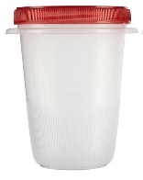For my Cuisinart immersion blender (CSB-75), this 4 cup Take-Along Rubbermaid container is perfect: you make it in what you put it away in. The cup that came with my Cuisinart didn't see to work as well. For the emulsification to work, the head of the immersion blender has to be a close fit in the bottom of the container…this Rubbermaid one is perfect. You can get it from Amazon pricey, but probably find it locally cheaper at a super market or hardware store  
<https://www.amazon.com/Rubbermaid-TakeAlongs-Twist-Storage-Container/dp/B003FAAB5Q>

[Wirecutter immersion blender review](https://www.nytimes.com/wirecutter/reviews/best-immersion-blender/)

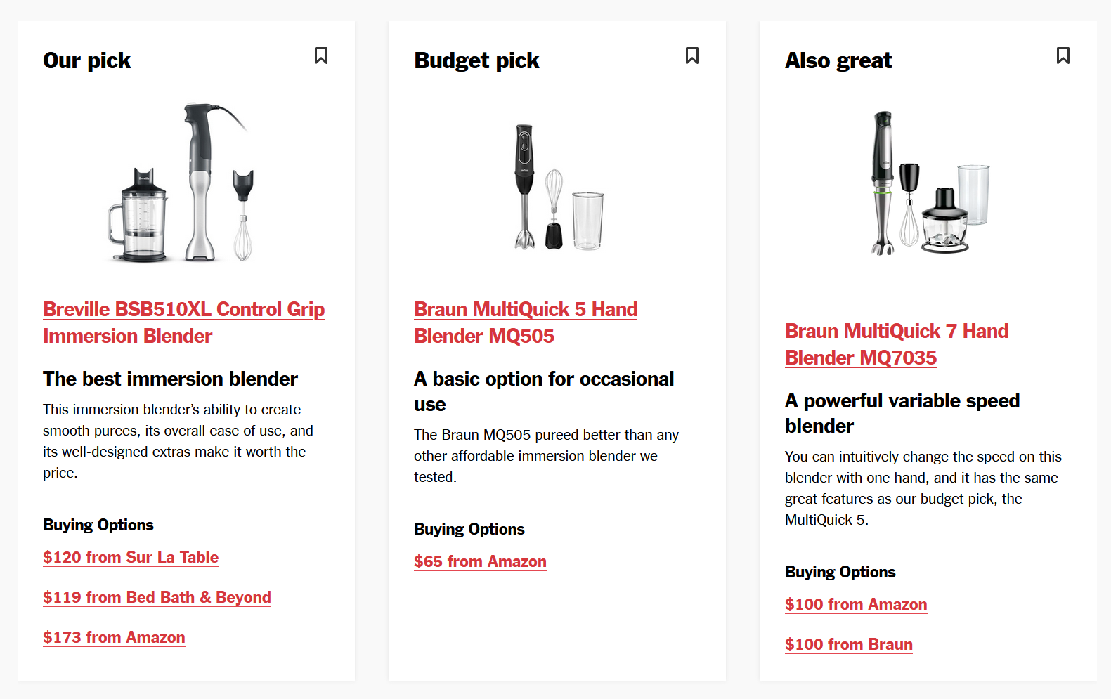

[CR](https://www.consumerreports.org/products/blenders-28971/immersion-blender-34525/)

